1. From the home page of your SharePoint site, open any list or library you would like, in this example I will open the “**Documents**” document library. 

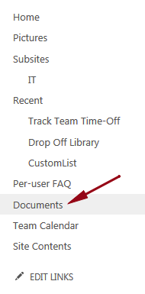

2. At the top of the page click **Library**, to expand the ribbon.

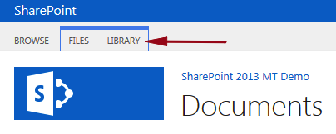

3. In the Manage Views section click **Create Column**.  
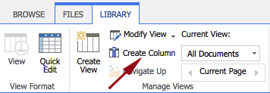

4. In the Name and Type section enter the following:

* Column name – **Purpose**
* The type of information in this column – **Choice**

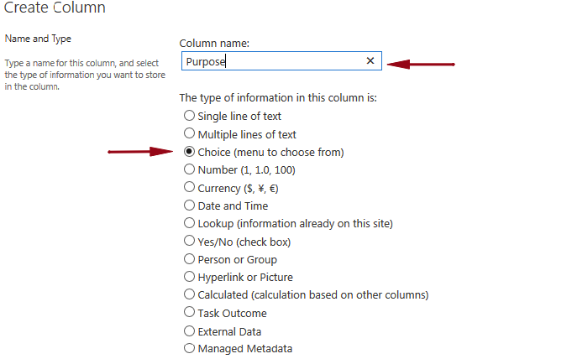

5.     In the Additional Column Settings section enter the following:

* Description - **Blank**
* Require that this column contains information – **No**
* Enforce unique values – **No**
* Type each choice on a separate line:

* + **Training Materials**
  + **Meeting Notes**
  + **Client Documentation**

* Allow 'Fill-in' choices – **No**
* Default Value – **Blank**
* Add to all content types – **Yes**

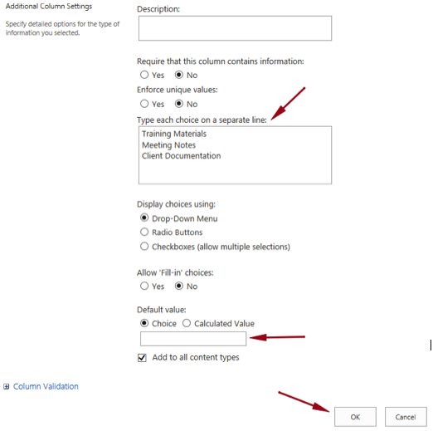

6. Click **OK**.

7. You will now see your new column added to this view.